THIRD TERM

SUBJECT COMPUTER STUDIES CLASS: S. S. S 1 DURATION:60MINS

- In Teleconference, the word ‘tele’ means ______.
a. Television b. Telephone c. Distance d. Time
- ______ Software is a category of application program used to create sequences of words and pictures that tell a story or help support a speech or public presentation of information.
a. Application b. Spreadsheet
c. Presentation Processing
- In Teleconference, the word ‘conference’ means _____.
a. federation b. consultation
c. computation d. none of the above
- _____ software enables you to create a more sophisticated presentation that includes audio and video sequences.
a. business presentation software
b. Multimedia authoring tool
c. System software d. None of the above
- ______ are basically devices used for information and communication technology.
a. computer system b. ICT based gadgets c. Information system Programming language
- The process of manipulating text data to produce a letter, report, memo or any other type of correspondence
Is known as _____.
- An electronic handheld device used to make mobile telephone calls is called _____. a. AutoCAD b. mobile phone
c. Trumpet d. Laptop
- The process of starting the computer and loading the operating system is known as ______. a. Booting b. Boot strap c. Starting d. Switching on
- The small images and objects that represent files, programs, web pages or command on the Windows desktop are referred to as _____
- To properly shut down your computer system, the first thing to do is to make sure all _____.
a. all running programs are properly closed b. all running programs are left running c. all running programs are disabled d. all of the above
- One of the following is NOT a type of teleconferencing.
a. web conferencing b. stage conferencing c. audio conferencing
d. video conferencing
- ______ is a two way voice communication among multiple locations in real time.
a. web conferencing b. stage conferencing c. audio conferencing
d. video conferencing
- “It is the transmission of image (video) and speech (audio) back and forth between two or more physically separate locations.” The above is a description of ______.
a. web conferencing b. stage conferencing c. audio conferencing
d. video conferencing
- The process where the computer prepares itself for proper operation is known as ______.
a. Welcome b. Desktop c. Booting
d. Cooling
- _____ are the small images and objects that represent files, programs, web pages or command.
a. pictures b icons c. graphics d. images
- The word processing program of the Microsoft Office suite that allows you to create documents and reports in known as _____. a. Ms Excel b. Ms Access
c. Ms Word d. Ms PowerPoint
- The automatic adjustment of the number of characters or words on a line; which eliminates need to press Enter key is called ______.
a. word wrap b. Word drop c. Word Rag
d. Word class
- The icons next to any ribbon group label in Ms Word which can be clicked to open a dialog box with more options for that group is known as _____.
a. Ribbon Groups b. Quick Access Toolbar c. Dialog Box Launchers
d. toolbar
- This icon is used for ______.
a. adding content to the clip board
b. removing the selection and putting it on the clipboard
c. put a copy of the selection on the clipboard
d. none of the above
- This icon is used for ______.
a. adding content to the clip board
b. removing the selection and putting it on the clipboard
c. put a copy of the selection on the clipboard
d. none of the above
- The keyboard short cut for “Find” is _____. a. Ctrl+c b. Ctrl+f c. Ctrl+r
d. Ctrl+g
- _____ is used to connect geographically separated people via high-quality audio and video streams.
a. Telepresence b. Television c. Telecast
d. Telephone
- In a _______, each participant sits at his or her own computer and is connected to other participants via the internet.
a. audio conference b. video Conference c. web conference d. none of the above
- What is LAN short for?
A. Linear Area Network B. Local Area Network C. Local Airborne Network
D. Localised Area Network
- Which of these is an input device?
A. CPU B. Headphones C. Power Supply D. Mouse
- Which of these is an output device?
A. Screen B. CPU C. Microphone
D. Power Supply
- Which port would you most likely plug a new scanner into on a modern computer?
A. Parallel B. USB C. Serial D. Firewire

For Question 28-32, name the following parts of the image bellow.
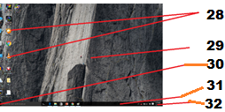

- What is the name of the above image?
a. computer b. laptop c. Windows desktop d. none of the above.
- In Windows 10, “All apps” can be found _____.
a. in the start menu b. in the task bar c. in the menu bar d. none of the above
- _____ is used to manipulates text data to produce a letter, report, memo or any other type of correspondence
a. Word processor b. Printer
c. Spreadsheet d. Copier
- In Ms Word, _____ produces dark or heavy print
a. italic b. bold c. center d. underline
- _____ defines how printed document will appear e.g. underline, boldface, print size, margin settings, line spacing, etc.
a. Grammar checker b. justified
c. Format d. Spelling checker
- _____ is the automatic adjustment of the number of characters or words on a line; eliminates need to press Enter key.
word wrap word rag word list word drop
- What is the name of this ICT based gadget?
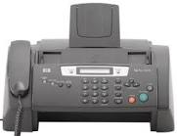
- Facsimile means _____. a. send image
b. make copy c. print copy d. delete image
IDENTIFY THE FOLLOWING
(QUESTIONS 41-50)
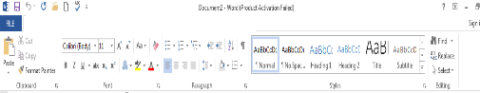
- Tab?
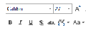
- 43. 44.
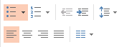
45. Tab?
46. Tab?


47. 48.

49.

50.

THEORY
ANSWER ONLY TWO (2) QUESTIONS FROM THIS SECTION.
1. Define Information and Communication Technology.
1b. state the uses of ICT
1c. identify the following ICT based gadgets.
i. 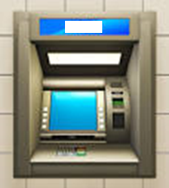 ii. 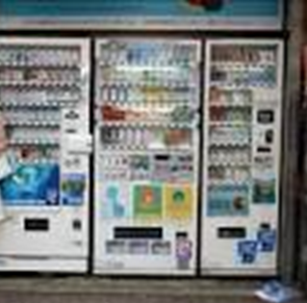
iii. 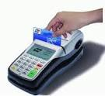 iv. 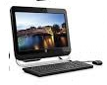
2. deferentiate detween word processing and word processor.
2b. State five(5) advantages of using a word processsor.
3. Explain the following word processor terminologies.
i. Bold ii. Center iii.Edit iv Font v. Format vi. Grammar chekecker vii Justified viii. Spelling checker
ix. Text data. Word wrap
4. i) DEFINE Teleconferencing. Ii. State its uses and ii) Explain the three types of Teleconferencing.
5. i) Define booting. Ii) Explain the types of booting. Iii) Explain the function of Bootstrap loader

